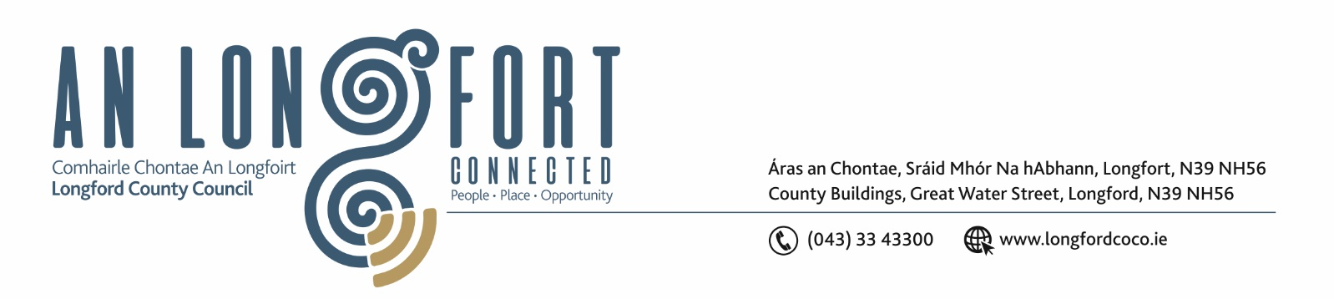

25th November 2019.

To: Each Member of the Joint Policing Committee.

Re: Meeting of the Joint Policing Committee

Dear Member,

I wish to inform you that the next meeting of the Joint Policing Committee will take place in the Council Chamber, Aras an Chontae, Great Water Street, Longford, on Monday, 2nd December 2019 at
3.00 p.m.

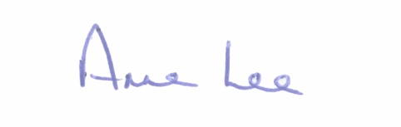
Yours sincerely,

___________________
Anne Lee,
Administrative Officer.

AGENDA

1. Confirmation of Minutes of Joint Policing Committee meeting held on the
30th September 2019 - enclosed.

2. Matters arising.

3. Declaration of Interest by Members.

4 To note apologies received.

5. Garda Report.

6. Local Authority Report.

7. Joint Policing Committee Public Meeting - consideration of questions submitted.

8. Update on Longford Joint Action Plan.

9. Item referred from October meeting of Longford County Council - Councillor Colm Murray.
- Control of cyclists using footpaths.

10. Election of Vice-Chairperson of Joint Policing Committee.

11. To fix dates for Joint Policing Committee Meetings in 2020.



